



**Disclaimer: The content is curated from online/offline resources and used for educational purpose only**

**LAB MANUAL**

**Unit VI – Image processing**

**Unit VI – Image processing**

**Lab 1. Forest Fire Detection Using Teachable machine**

**Objective**

The primary goal of this project is to build a machine learning model using Teachable Machine to detect forest fires in real-time from images.

**Problem**

Forest fires are one of the most devastating environmental disasters, often leading to the destruction of wildlife, loss of biodiversity, and damage to ecosystems. Timely detection of forest fires is critical for minimizing damage and enabling early intervention. However, traditional methods of fire detection, such as manual observation or relying on sensors, can be slow, costly, or inaccurate in remote areas.

The problem lies in detecting forest fires in real-time, especially in vast and often inaccessible regions. There is a need for a scalable, cost-effective, and accurate solution that can detect signs of forest fires (such as smoke or unusual heat) quickly and autonomously.

**Solution**

following steps:

1. Import required libraries
2. Prepare the dataset
   1. Load dataset
   2. Select Features and target variable
3. Train a Random Forest Classifier model
   1. Split the dataset into training and testing sets (80% train, 20% test)
   2. Initialize and train the Random Forest Classifier model
4. Evaluate the model
   1. Predicting Classifying Waste Types output on the test set
   2. Evaluate the model performance
5. Visualization
6. Save the model for later use
7. Load and use the Model

**Procedures**

**Training the Model with Teachable Machine**

1. **Open Teachable Machine**:
   * Go to Teachable Machine. (https://teachablemachine.withgoogle.com/)
   * Choose the **Image Project** option and then **Standard Image Model**.

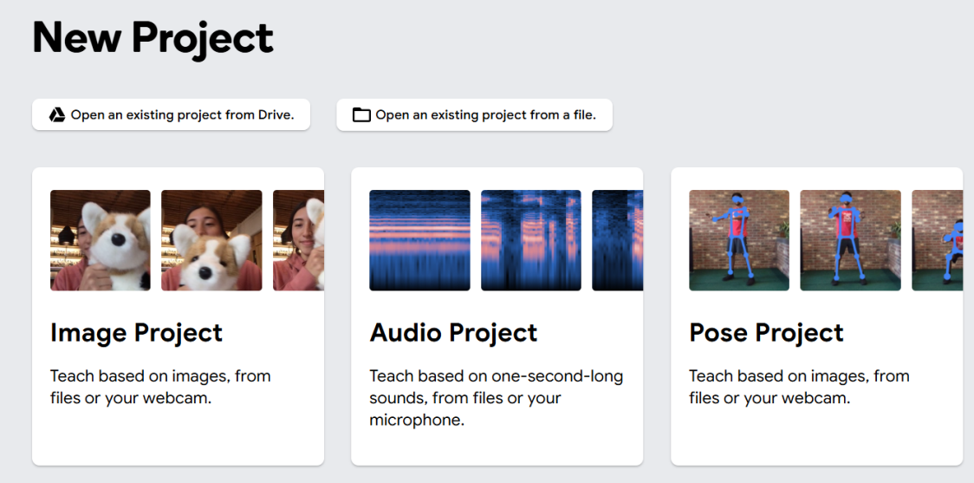

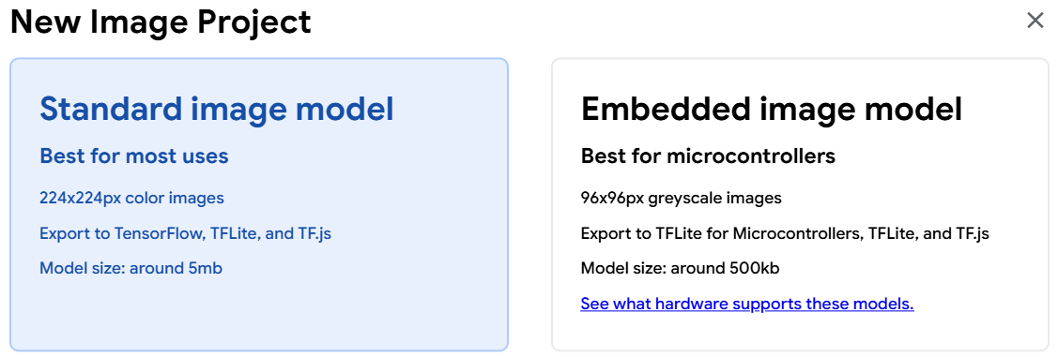

1. **Set Up Classes**:
   * By default, Teachable Machine gives you a class labeled “Class 1.” Rename it to “fire.”
   * If required, Click **Add a Class** for each waste type, and rename them as “nofire”

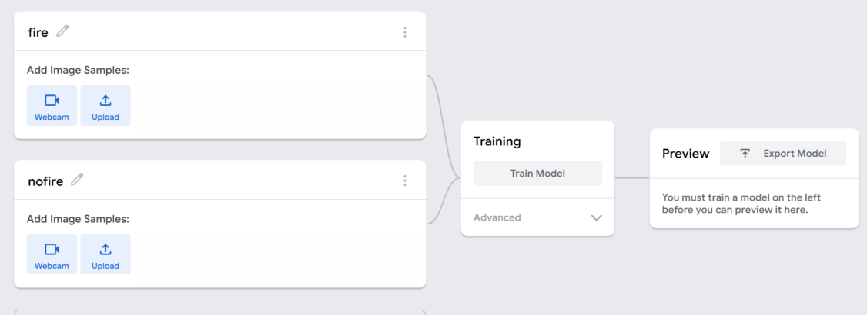

1. **Upload Images**:
   * For each class, upload your prepared images.
   * Make sure each waste type has enough examples for the model to learn distinct features. The more images, the better the model’s performance.

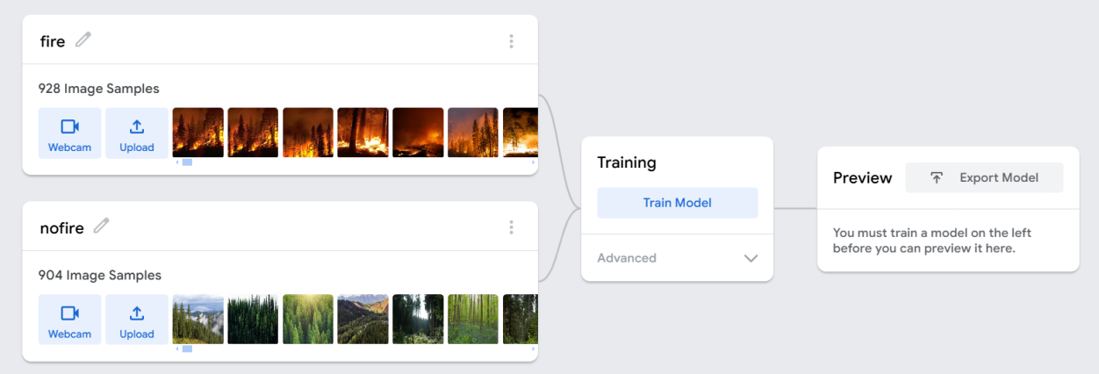

1. **Train the Model**:
   * Once images are uploaded and categorized, click on the **Train Model** button.

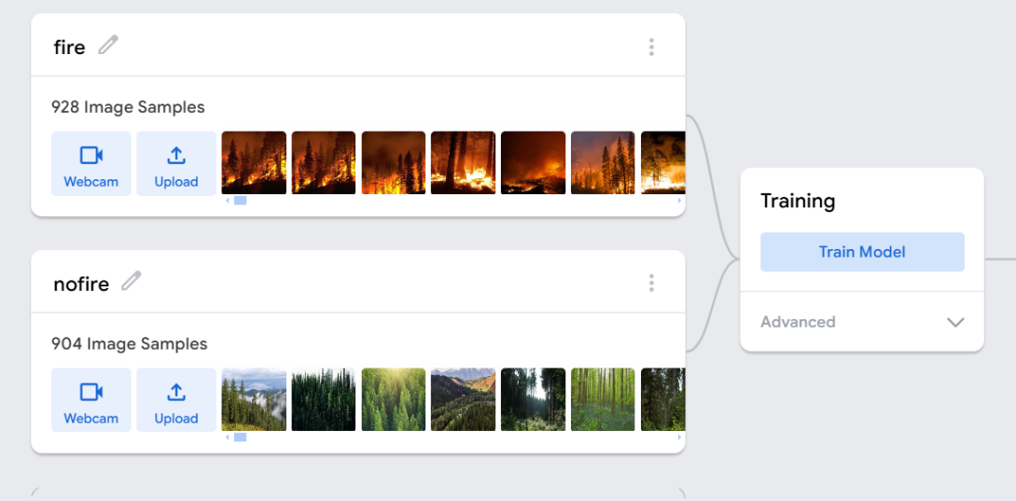

* + Teachable Machine will process the images, building a model that recognizes patterns in each category.

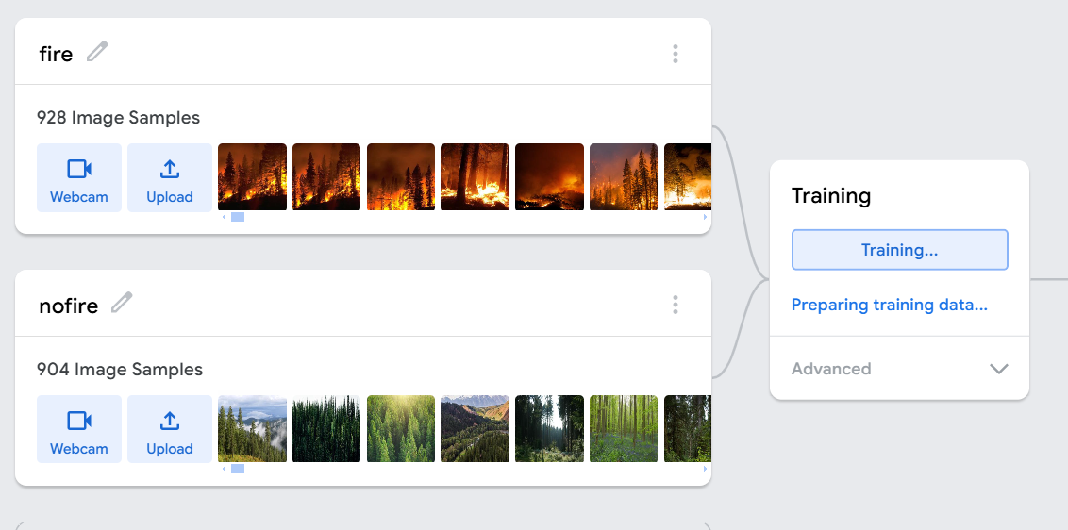

After started,

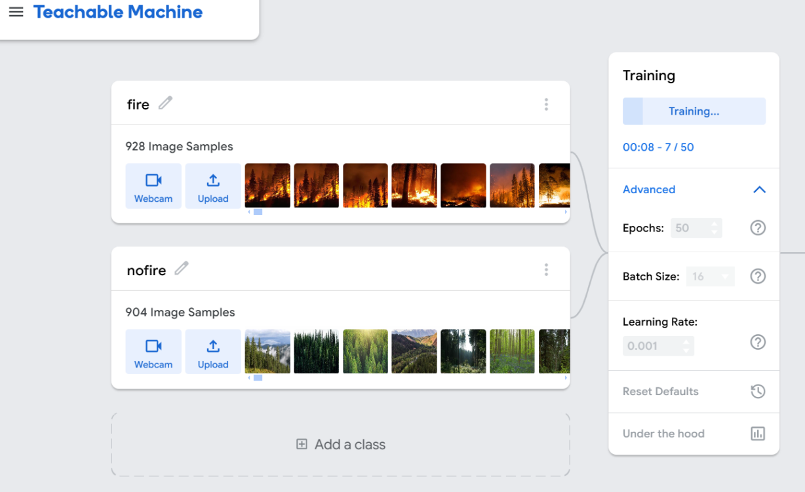

1. **Testing the Model**:
   * After training, test the model by uploading or using the webcam to capture new images of each waste type.

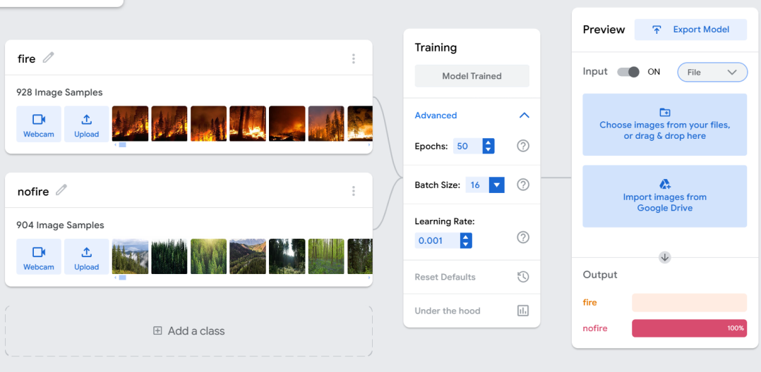

* + The model will display predictions, showing the likelihood that an image belongs to each category.

Nofire output:

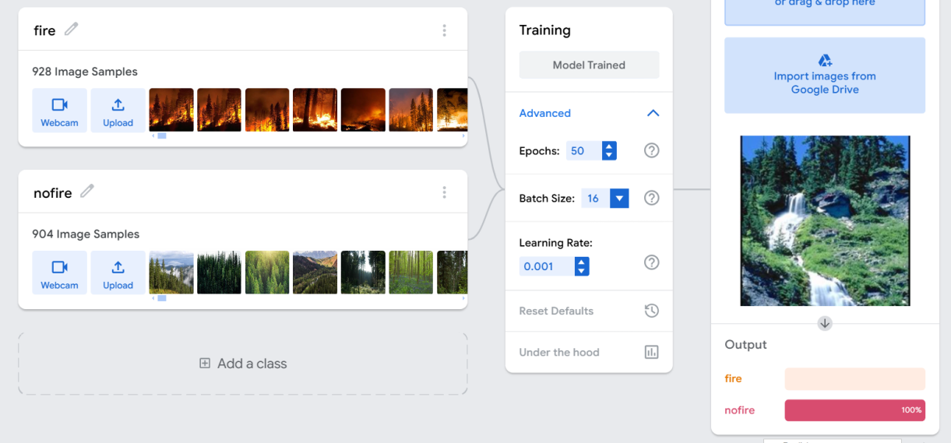

Fire Output:

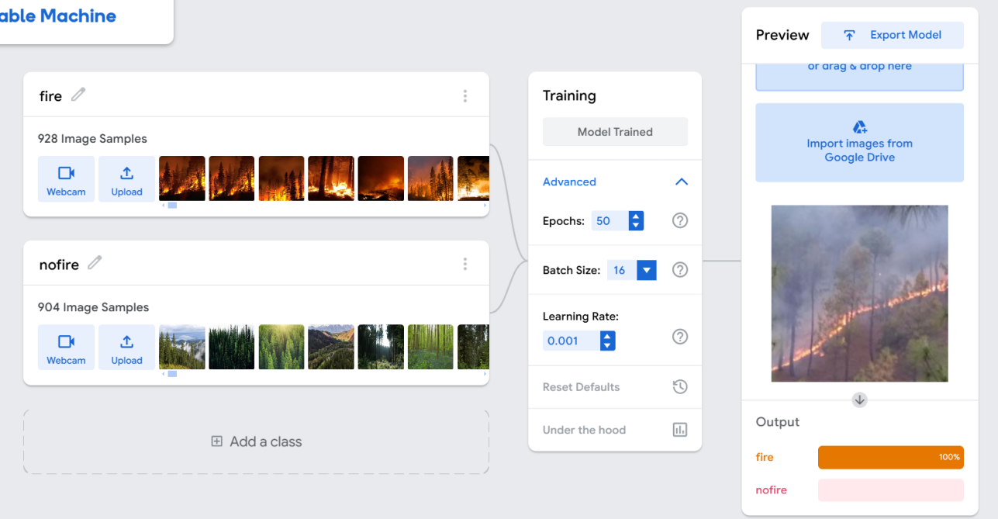

**Export Model**

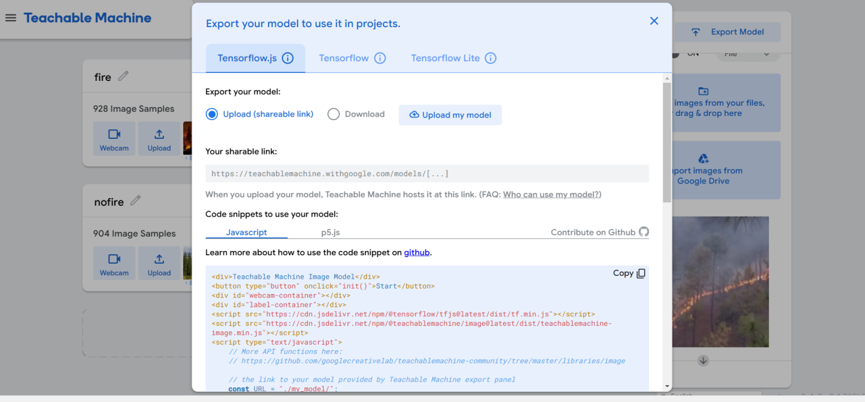

We can use in different in app development.